GOAL: To update [SMART cancer navigator](https://smart-cancer-navigator.github.io/) code to make use of the [VICC meta-kb](https://search.cancervariants.org/)

Currently, for a given variation, the “Variant” tab contains a list of effective drugs and known diseases. The MetaKB provides information on the associations between variants, drugs, and diseases together with supporting info and AMP/ASCO/CAP evidence labels.

Approach:

1. Analyze app structure and add association (Xiaotong)
2. Analyze current content structure for optimal integration of association data (Jamie/Jeremy)
3. Integrate data into app using best practices
4. Add writeup to FHIR Genomics paper

(current ideology behind database search capabilities and representation in the app prototype below)

Descriptions: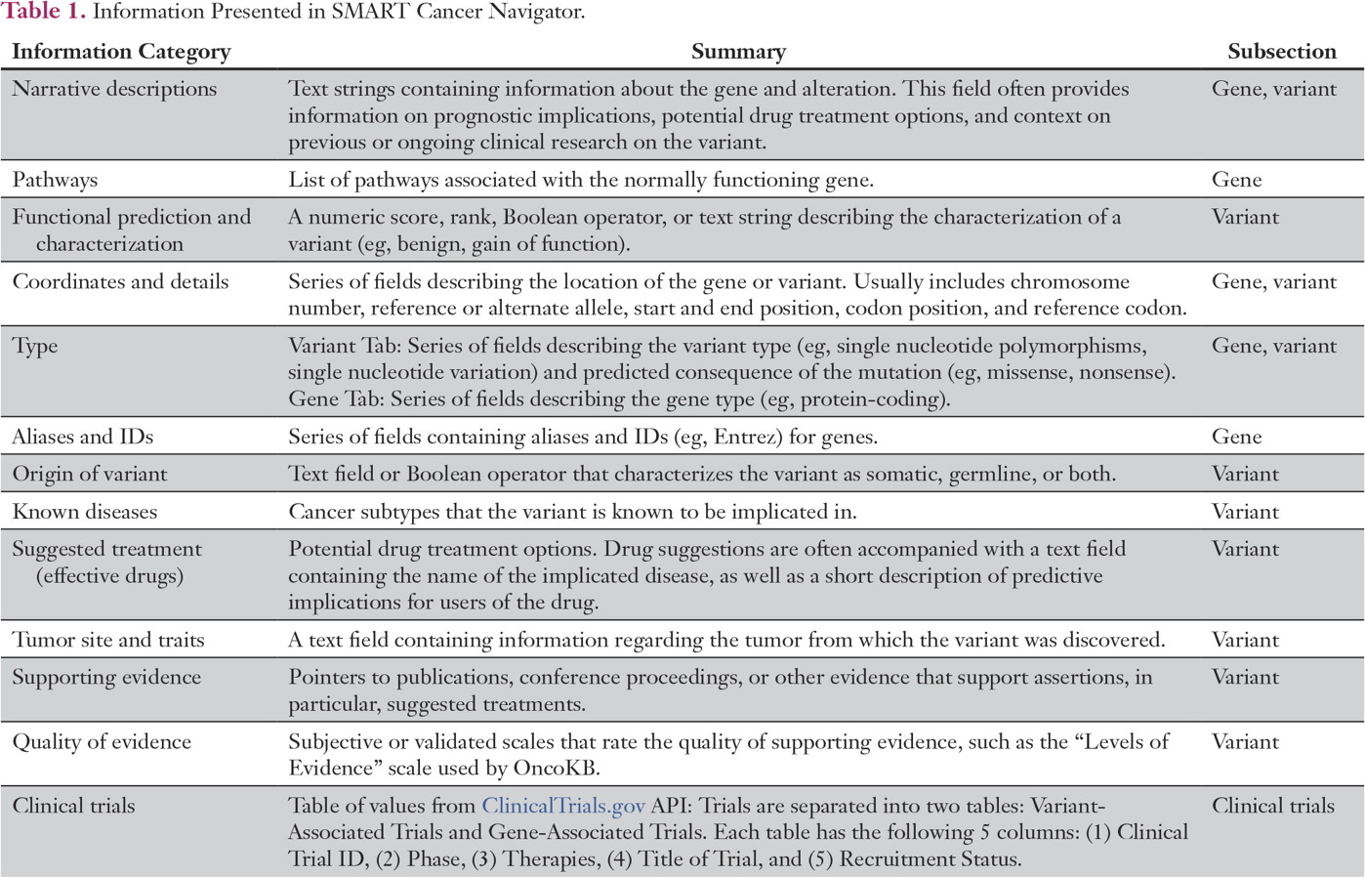

* CIViC
* PMKB
* MyVariant.info
* MyGene.info

Functional prediction

and characterization

* DbNSFP
* With the following prediction algorithms and services exposed in the API:
  + DANN
  + Eigen
  + Ensembl
  + Exac
  + FATHMM
  + GenoCanyon
  + Gerp++
  + gm12878
  + h1-hesc
  + lrt
  + m_cap_store
  + metal
  + metasvm
  + mutationassessor
  + mutationtaster
  + mutpred
  + phastcons
  + phylo
  + polyphen2
  + Provean
* ClinVar

Coordinates and Details

* CIViC
* ClinVar
* COSMIC
* CADD
* dbNSFP
* dbSNP
* MyVariant.info
* MyGene.info

Type

* CIViC
* ClinVar
* CADD
* dbSNP
* MyGene.info

Origin

* CIViC
* ClinVar
* dbNSFP

Known Diseases:

* CIViC
* MyVariant.info

Suggested Treatment:

* CIViC
* CGI
* DGIdb

Tumor site and traits:

* COSMIC
* dbNSFP
* PMKB

**Looking forward:**

==================================================================

Searching for a given HGVS_id on associations (search.cancervariants.org) returns a list of hits, each with:

An association object with:

**variant_name**

description

drug_labels

environmentalContexts (list of objects) with **id** (RxNorm)

An “evidence” implication (description = “sensitivity”, info.publications (list)

evidence_label “C”

evidence_level 3

Some **Phenotypes** (coded in obolibrary.org)

A separate **publication_url**

response_type “Sensitivity”

source_link

also:

**diseases**

**drugs**

**response_type**

**Evidence_label** (“C”)

**Evidence_level** (3)

feature_names

features (a bunch of SO stuff!, potentially list of “**hgvs**” ids)

gene_identifiers entrez_id, symbol, ensembl_gene_id

**Approach Outline (hoping to finish parts 1-3 by wednesday 8/14 ~11a)**

1. Write a new service to query cancervariants.com based on the given hgvs_id (based off of mygeneinfo-search.service.ts)
2. Show the results in a table on a new tab (
3. For each hit in the response, map it to the fields in an “**association”** object that Jamie writes up (can just put it all in as text at first)
4. Write a new component/tab (based off variant-information.component.ts) that displays the info for each association.
5. Add a new tab to varian-visualization.component.ts to display the new table

Sample hgvs id:

BRAF (gene) V600E

Can search <https://search.cancervariants.org/api/v1/ui/#!/Associations/searchAssociations>

with q=chr7\:g.140453136A>T

Update 8/12:

X Added component and service for associations, need to refactor upstream to get called

JJ: Great work!

**Next steps 8/12 (this approach was not used, separate component/service were created)**

1. Add Association search service to original Injectible on **variant-selector.service.ts**
   1. Add the database and interface
   2. Add a public search function to get associations from a variant
2. Call the new search function on **variant-entry-and-visualization.component.ts**

**Next next steps 8/12:**

Currently the code takes a search term and creates a Variant object, which then has a FHIR representation which gets attached to the patient.

Once this variant is created (or grabbed by the SMART api from the patient’s medical records), we want to THEN search for associations and create Assoc objects in FHIR and add those to a tab to be displayed.

**Update 8/13**

Table generating on Association tab

1. Provide top 20 for now
2. Try to figure out the api “sort” function - want to prioritize results by evidence_level (1-4)
3. Idea I believe, is to aggregate associations based on drugs and diseases, but don’t want to get too far into visualization work down a different direction than needed...
   1. Wow! Push the new code to github and I’ll show it off to Dr. Warner

**8/19**

Next goal:

1. Replace the drug and disease information on the Variant tab with updated version on the Associations tab
   1. Remove current drug/disease info
      1. Can comment out adding the drugs and diseases in **myvariantinfo-search.ts**
      2. **Remove html on variant-information-component.ts**
   2. Don’t display the tables immediately on Associations
   3. Instead, mirror the current display on Variant for drugs and diseases (just for the current gene/variant):
      1. Display drug names in clickable widget (code in **drug-details-modal.component**)
      2. Drug Components would display table of relevant hits for
         1. *Response, evidence label, publication URL*,
         2. Add environmentalContexts.id into the header/description for the drug
      3. Copy this for diseases (write new **disease-details-modal.component**)
         1. Disease components would display table of relevant hits for
            1. *Response, evidence label, publication URL*
            2. Add *phenotype* into the header/description for the disease

**8/20** LOOKIN GOOD

1. Try squaring the color factor so middling entries are less colored
2. Add source_url as a new column on the modal components
3. Add association.description as a tooltip over the source_url
4. Comment out the bottom table on assocs and the disease list on variant tab

(Jamie FHIR part notes) in **variant-entry-and-visualization.component.ts**

1. Create FHIR <http://build.fhir.org/ig/HL7/genomics-reporting/obs-som-predictive.html> for drug assocations on the variant object
2. Create FHIR <http://build.fhir.org/ig/HL7/genomics-reporting/obs-som-diagnostic.html> for disease assocations on the variant object

Later money:

Add a button to association tab to enter an association into the EHR as a FHIR-IG coded observations~